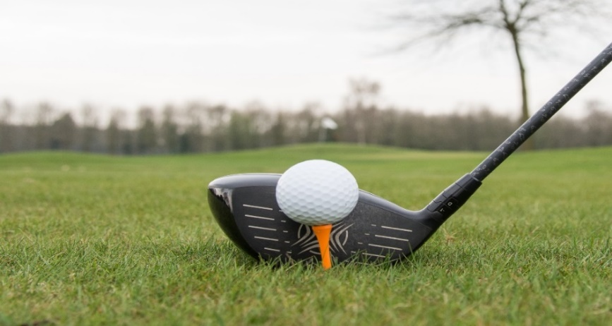

24th Annual Blue Goose Honker Classic

In aid of Special Olympics Nova Scotia

Monday, June 17th , 2024

Chester Golf and Country Club

222 Golf Course Road Chester NS

Sponsorship Opportunities

*Sponsorship & Payment Deadline – June 7th, 2024*

Hole Sponsorship (not incl meal) $350.00 Hole requested ________

Cost per meal $40.00 Number of meals _______

Tournament Contest Sponsorship:

Closest to the hole _______________ Men ___________ Woman

Longest Drive _______________ Men ___________ Woman

Closest to the line _______________ Men ___________ Woman

Contest of your choice ________________________________

Door Prize Sponsorship _______________ Individual _______ Team

***Please specify prize(s) ________________________________

|  |  |  |
| --- | --- | --- |
| Name/Company | Telephone# | Contact email |
|  |  |  |

Please go to [24th Annual Blue Goose Honkers Golf Classic - CanadaHelps](https://www.canadahelps.org/en/charities/special-olympics-society-of-nova-scotia/events/blue-goose-honkers-golf-classic/) and follow the link to complete the registration. If paying by credit there will be a link when you register.

If you are paying by e-transfer, please e-transfer **mgreek@specialolympicsns.ca**

Cheques are payable to Blue Goose Nova Scotia Pond, addressed to Special Olympics 100-371 St. Margaret’s Bay Rd. NS B3N 1J8 Attention Michael Greek.

Any questions regarding sponsorship contact tdoane@systemcare.ca or 902-237-7361

We thank you on behalf of the Blue Goose and Special Olympics

